

APPENDIX B
SOUTHERN CALIFORNIA PUBLIC POWER AUTHORITY
Q3/Q4 2025 Renewable Energy Resources and Energy Storage Solutions RFP
Energy Storage Specifications
[Project Name]

This document contains requirements specific to proposals for the Los Angeles Department of Water and Power (“LADWP”). The LADWP and the “Buyer” shall be used interchangeably. This document shall be completed and submitted with the Respondent’s proposal package.

Note: Where requested, Seller shall check appropriate boxes indicating whether Seller agrees, disagrees, or acknowledges provisions as stated. If Seller disagrees, Seller shall provide a description of specific point(s) of disagreement and a proposed counterproposal, where applicable. Omission of a response to the required field will render the proposal incomplete and subject to disqualification.

The requirements for proposals to be submitted to SCPPA for projects in the LADWP BAA in response to this RFP effort are detailed in this Appendix and the Energy Storage System (ESS) Specifications Datasheet (Exhibit 1). Proposals that do not meet these requirements will be considered non-responsive and disqualified from further evaluation, unless otherwise specified.

- Energy Storage System (ESS) Proposal Requirements
1. |  | The ESS requirements in this Appendix are technology agnostic, provided that the ESS:  - Shall meet all requirements and technological specifications of this Appendix, including all prerequisite activities, such as entity registration, which is mandated by applicable NERC Reliability Standards and shall be completed prior to the in-service date of the project.  - Shall interconnect to the LADWP grid with revenue grade metering.  - Shall interconnect at transmission level only (greater than 100kV).  Agree ___________ kV Disagree  Comments:
2. |  | The ESS shall consist of utility scale commercially available technology with a Technology Readiness Level of at least 7.. The Agreement term for energy storage systems (BESS) shall be equivalent to the Renewable Energy Resources and Energy Storage Solutions Agreement term.  Agree Disagree  Comments:
3. |  | The Seller shall be an experienced project developer with at least one member of the development team having (a) completed at least one project of similar technology, or (b) begun construction of at least one other project similar to the proposal being submitted by the time of the submittal. Please include the prime proposer and all subcontractor’s experiences and resumes, with their respective roles in each project using a separate file, named Exhibit 2.  Agree Disagree  Comments:
4. |  | The ESS shall be installed, delivered, repaired, augmented, and maintained by the Seller; however, the Buyer shall have full operational control over the ESS.  Agree Disagree  Comments:
5. |  | All ESS warranty terms and limitations shall be explicitly stated in the proposal.  Agree Disagree  Comments:
- ESS Codes and Standards
1. | The ESS shall be developed and installed in accordance with all applicable laws, best industry practices, and pertinent standards for the applicable technology, and in consultation with LADWP and the local jurisdiction’s Authority Having Jurisdiction (AHJ). The ESS shall comply with the latest version of applicable codes and standards at the time of the detailed engineering phase. The Seller shall indicate any exceptions to this list and provide supporting explanations. Codes and Standards include, but are not limited to the following:  - Institute of Electrical and Electronics Engineers (IEEE) Standards 1547, 1547.1, 693, 519  - UL Standards 9540, 9540A, 2054, 62133, 1741, 1741SA, 1998, 1642  - National Fire Protection Association (NFPA) Standards 855, 68, 69, 72, 70, 1  - International Fire Code (IFC) 2018/2021  - United Nations/Department of Transportation (UN/DOT) 38.3  - National Electric Code (NEC)  - American National Standards Institute (ANSI) C84.2006  - International Electrochemical Commission (IEC) 62933-5-2  Agree Disagree  Comments:
2. | The Seller shall comply with the following codes and standards:  - LADWP’s Cyber Security and Physical Security Standards, which will be provided during negotiations.  - North American Electric Reliability Corporation (NERC) Reliability standards, such as PRC – 024-3, and Buyer’s requirements, including Critical Infrastructure Protection (CIP) Standards for the ESS.  - Recommended performance specifications set forth in the NERC Reliability Guideline: BPS-Connected Inverter-Based Resource Performance, as published during the design period, based on the BESS’ proposed COD.  Acknowledge  Comments:
3. | The Seller shall describe and be responsible for any required environmental compliance, such as the California Environmental Quality Act, or permits for the project. Criteria pollutants and gas emissions must be disclosed in the ESS Specifications Datasheet (Exhibit 1). Examples include, but are not limited to:  - A permit-to-operate required by the local Air Quality Management District if the equipment generates emissions of criteria pollutants (VOC, NOx, SOx, CO, PM), or if an emergency generator greater than fifty (50) horsepower is installed.  - A National Pollutant Discharge Elimination System Permit if the equipment discharges into waters of the United States.  - Material Safety Datasheet (MSDS) development, hazardous material removal, and dust mitigation/control measures.  Agree Disagree  Comments:
4. | List additional codes and standards, if applicable:

- Technology Specifications, Project Information, and Guarantees
- Technology Specifications
a. | Select the operational capabilities and operating restrictions of the proposed technology and include all Control Modes that the ESS can perform (See Table 1 for details).
  Control Mode Category | Control Mode
  Emergency Modes | ☐ 1. Voltage Ride-Through
  Emergency Modes | ☐ 2. Frequency Ride-Through
  Emergency Modes | ☐ 3. Dynamic Reactive Current
  Emergency Modes | ☐ 4. Dynamic Volt-Watt
  Emergency Modes | ☐ 5. Frequency-Watt (Implement NERC Reliability Guideline: BPS-Connected Inverter-Based Resource Performance)
  Emergency Modes | ☐ 6. Frequency Droop
  Active Power Modes | ☐ 7. Charge-Discharge Storage
  Active Power Modes | ☐ 8. Coordinated Charge-Discharge
  Active Power Modes | ☐ 9. Active Power Limit
  Active Power Modes | ☐ 10. Active Power Response (configurable as Peak Power Limiting, Load Following, or Generation Following modes)
  Active Power Modes | ☐ 11. Automatic Generation Control
  Active Power Modes | ☐ 12. Active Power Smoothing
  Active Power Modes | ☐ 13. Volt-Watt
  Active Power Modes | ☐ 14. Frequency-Watt Curve
  Active Power Modes | ☐ 15. Pricing Signal
  Reactive Power Modes | ☐ 16. Fixed Power Factor
  Reactive Power Modes | ☐ 17. Volt-VAR Control
  Reactive Power Modes | ☐ 18. Watt-VAR
  Reactive Power Modes | ☐ 19. Power Factor Correction
  Other | ☐ 20.
b. | Lithium-ion BESS shall provide a minimum of 365 equivalent cycles per calendar year or 366, as applicable for leap years. The number of cycles for other technologies shall be included in the proposal. Cycling during the Annual Performance Test shall not be included in the minimum cycles per year. The Buyer reserves the right to request additional cycle, for a fee, if needed.  Agree Disagree  Comments:
c. | The ESS shall be capable of providing between ±0.8 power factor at the Point of Interconnection (POI).  Agree Disagree  Comments:
d. | The Buyer shall be able to curtail renewable energy resources paired with ESS without a phone call notification. The Buyer shall have direct control of ESS.  Agree Disagree  Comments:
e. | ESS shall have a minimum capacity of one half of the total renewable resource capacity, with a minimum duration of four (4) hours at the POI or otherwise specifically stated in the requirement for each project. The Buyer will consider durations longer than 4 hours if it is economically feasible.  ____________ MW ____________ MWh  Comments:
f. | The ESS shall support Modular Energy System Architecture (MESA)-ESS communication standards as well as DNP3 protocol capability to communicate with SCADA.  Agree Disagree  Comments:
* A frequency function/set point is needed to facilitate LADWP’s compliance to NERC Reliability
Standard BAL-003-2, requirement R1 or its successor.

1) | The Control Modes in Table 1 are from the MESA-ESS Specification, and reference shall be made to either the MESA-ESS Specification or IEC 61850-90-7, or standard mutually agreed upon by the Buyer and the Seller. Table 1 through Table 6 are centered on Lithium-ion BESS and not all sections may be applicable to all ESS technologies. The Seller shall indicate the portions not applicable in the proposal.  Agree Disagree  Comments:
g. | The ESS shall establish a connection to external communications in the form of at least: one console for the Buyer’s Energy Management System (EMS) and one console for local control.  Agree Disagree  Comments:
h. | Seller shall provide LADWP with Back-up Automatic Generation Control for the ESS.  Agree Disagree  Comments:
i. | The Control Modes shall consist of settable functional parameters that trigger responses that the ESS can provide. The operation of any Control Mode or simultaneous Control Modes are subject to the ESS Limitations, Control Mode setpoints and priorities (as specified and scheduled by the Buyer), and the ESS conditions (i.e. SOC, temperature, etc.) at the time of operation of such Control Mode(s). The Buyer shall have the ability to provide Control Mode set points for charge and discharge of the ESS as well as the ability to set specific MW charge and discharge values and priorities, subject to those limitations and conditions. All functions should be operable from the Buyer’s EMS via DNP3.  Agree Disagree  Comments:
j. | The Seller shall provide D-Curve for all 4 quadrants (MVAR output vs. MW output) at all power factors to the Buyer.  Agree Disagree  Comments:
- Project Information
a. | An ESS proposal shall include information or drawings on each of the elements below in a separate file, named Exhibit 3. Indicate N/A (with explanation) if not applicable to the proposal:  - Site Plan Drawing  - General arrangement drawing or site map with balance of plant included, for reference purposes.  - Electrical one-line diagram  - Evidence of interconnection application and payment  - Demonstration of site control in the form of ownership, lease or license, or irrevocable option for ownership, lease, or license  - Project milestone schedule and timeline of necessary permits  - Supply plan information (including how and where to source materials, supply chain risks and mitigation, and components for energy storage)  - Environmental: Potential hazards and mitigation plan  - Project emergency response plan that describes the associated hazards and risks, training, and emergency actions to be taken  - Hazard and operability (HAZOP) Study or equivalent. HAZOP studies are used as part of a Quantitative Risk Assessment or as a standalone analysis.  - Additional reports, such as independent engineering reports, arc flash studies, preliminary front-end engineering design studies, etc. to assist LADWP’s evaluation of the proposal  - Enclosures: Type (container, trailer, building), quantity, and dimensions  - Rack: Dimensions, quantity of racks  - Module: Capacity, quantity of modules per rack  - Transformer: Model number, transformer type, primary voltage, secondary voltage, power rating  - Battery Management Systems: Model and manufacturer  - Communication: Required equipment  - Control Systems: Related software, model, and manufacturer  - Other: Related auxiliary equipment required  - Thermal Regulation System: Type (HVAC, water cooling, etc.)  - Fire prevention, detection, notification, suppression, and protection systems  - Capacity and ancillary services operating restrictions  - Guidelines and procedures for safe handling and disposal of damaged equipment or defective battery cells and modules, if applicable.  - Project decommissioning plan. Include key system and installation information that helps inform the Buyer about system decommissioning, end-of-life disposal/recycling process with potential vendors.

- Guarantees
a. | The Seller shall ensure that the ESS charge capacity (MW) and discharge capacity (MW) matches the ESS Guaranteed values, as declared in Exhibit 1, throughout the Agreement term. If the ESS charge or discharge capacity falls below the Guaranteed values at any time, the ESS will be considered unavailable.  Agree Disagree  Comments:
b. | Lithium-ion BESS shall maintain its Guaranteed Energy value until the last five (5) years of the Agreement. During the last five (5) years of the Agreement, the energy may degrade by up to three (3) percent of the ESS Guaranteed Energy value per year.  Non-Lithium-ion ESS energy shall match the Guaranteed ESS Energy value for the entire term of the Agreement.  The Seller shall provide a degradation curve for the term of the Agreement as a separate attachment, titled Exhibit 4.  Agree Disagree  Comments:
c. | The ESS shall be capable of continuous discharge from 100% State of Charge (SOC) to 0% SOC and continuous charge from 0% to 100% SOC at the Guaranteed charge and discharge capacity. 100% SOC shall be equal to the Guaranteed ESS Energy during the entire term of the Agreement.  Agree Disagree  Comments:
d. | The ESS shall maintain Availability based on the calculation in Figure 1.  For the entire term of the Agreement, the applicable Monthly Guaranteed Availability values are:  - 98% if proposed technology is lithium-ion battery  - Monthly Guaranteed Availability for non-lithium-ion technologies shall be negotiated  Agree Disagree  Comments:
e. | The Seller shall provide outage notification at least thirty (30) days in advance via email with start and end dates of such outage, subject to the Buyer’s approval.  If SCADA control for ESS is not available or ESS is not visible via SCADA to the Buyer’s Energy Control Center, then the ESS shall be considered unavailable, unless otherwise specified by the Buyer. The Seller shall coordinate the timing of ESS augmentation with the Buyer to ensure optimal timing and minimal interference and disruption to the Buyer.  Agree Disagree  Comments:
f. | If the ESS fails to achieve the Monthly Guaranteed Availability, the Seller shall remedy such failure by paying liquidated damages shown in Figure 2.  If BESS Monthly Guaranteed Availability remains below 90% beyond the agreed cure period, not including planned outage or curtailment at the Buyer’s discretion, the BESS shall be considered in default.  For ESS technologies other than lithium-ion BESS, Monthly Guaranteed Availability Requirement for Default described above shall be modified on a case-by-case basis during negotiations.  The Seller shall guarantee the performance of the ESS in accordance with the Annual Performance Test requirements and procedures for the selected parameters (“Guaranteed ESS Parameters”) listed in the Section D.3.gfor the entire term of the Agreement. If the ESS fails the Annual Performance Test, the Buyer’s payment to the Seller shall be subject to reduction by the liquidated damages until ESS passes a subsequent performance test which is separate from the Annual Performance Test.  Agree Disagree  Comments:
g. | The following ESS Guaranteed Parameters shall be tested by the Seller and provided to the Buyer for comparison against the appropriate expected values provided in Exhibit 1 at the COD Performance Test and during the Annual Performance Test. All parameters measured at the POI.  - Round-Trip Efficiency (RTE) (%)  - Continuous Charge Capacity (MW)  - Continuous Discharge Capacity (MW)  - Guaranteed ESS Energy (MWh)  - Active Power Response Time (Time required for the ESS to ramp up to full capacity from when the Buyer issues the signal).  - Guaranteed up-ramp rate for full power charge and discharge operation (MW/[time])  - Guaranteed down-ramp rate for full power charge and discharge operation (MW/[time])  Agree Disagree  Comments:
h. | In addition to the ESS parameters listed in Section D.3.g, the following ESS parameters shall also be tested through the COD Performance Test and match the appropriate expected values provided in Exhibit 1 to declare COD.  - Full-rated continuous Power Rate (Charge and discharge at full rated power capacity for sustained periods of time.) (MW)  - Half-rated Continuous Power Rate (Charge and discharge at ½ of full rated power capacity for sustained periods of time.) (MW)  - Minimum time required to charge from 0 to 100% SOC at full rated capacity  - Maximum time required to charge from 0 to 100% SOC at full rated capacity  - Energy Available for immediate discharge at 100% SOC (MWh)  - Charge Ramp Rate (MW/[time])  - Discharge Ramp Rate (MW/[time])  - Discharge Ramp Rate after synchronization (%/sec)  - Self-discharge (% SOC/day)  - Noise (dBA)  - Startup time (min)  - Shutdown time (min)  Agree Disagree  Comments:
i. | Payment for ESS shall be performance-based and made in full if all performance parameters are met. A monthly performance report shall be provided as a pre-requisite for payment. Invoices shall be paid after the Buyer approves the monthly performance report. Payment shall be reduced for underperformance.  Agree Disagree  Comments:

- ESS Operation and Reporting Requirements
1. | The Buyer shall have the following control over the ESS:
a. | The ability to schedule specific SOC values for the ESS to achieve by a set time. The ESS shall calculate and execute the charge or discharge profile to achieve that setting.  Agree Disagree  Comments:
b. | The ability to specify a charge and discharge MW set point that shall override existing operations/schedules to execute immediately based on the latest NERC Reliability Guideline: BPS-Connected Inverter-Based Resource Performance.  Agree Disagree  Comments:
2. | All ESS metering shall comply with the applicable metering policies and requirements from the LADWP Bulk Electric System Meter Policy.  Agree Disagree  Comments:
3. | The Seller shall be responsible for the ESS complying with applicable policies and all requirements for the Energy Imbalance Market.  Agree Disagree  Comments:
4. | The ESS shall be registered with the California Independent System Operator (CAISO) following the New Resource Implementation Process. The Seller shall assume such resource will become a participating resource in the Buyer’s portfolio and be accepted by CAISO on COD.  Agree Disagree  Comments:
5. | The Seller shall provide regular reporting of ESS status to the Buyer via SCADA including, but not limited to the following:  - Number of cycles and MWh remaining for ESS cycling for the year  - MW and MVAR available for charge and discharge  - MWh available for charge and discharge  - MWh discharged year to date  - Estimated time needed to charge from current SOC to another Operator- specified SOC  - Estimated round-trip efficiency, based on total MWh charged and discharged per month. For clarification, this does not establish the round-trip efficiency of the ESS as described in the Annual Performance Test or as part of the COD Performance Test.  Agree Disagree  Comments:
6. | WECC/NERC Generator Testing and Model Validation Requirement: The Seller shall comply with Western Electricity Coordinating Council (WECC) Generator Testing and Model Validation Requirements and shall provide Buyer with the required documents for compliance, as applicable.  Agree Disagree  Comments:
7. | EIA Requirement: The Seller shall be responsible for the U.S. Energy Information Administration (EIA) data submittals. A copy of any submitted reports shall be provided to the Buyer upon submittal to EIA.  Agree Disagree  Comments:
- Pricing
1. | Seller shall provide project pricing as specified in Exhibit 1. This pricing shall be separate from the renewable resource price.  $ __________ / MWh  Comments:

Table 1: CONTROL MODES
Control Mode Category | Control Mode
Emergency Modes | 1. Voltage Ride-Through
Emergency Modes | 2. Frequency Ride-Through
Emergency Modes | 3. Dynamic Reactive Current
Emergency Modes | 4. Dynamic Volt-Watt
Emergency Modes | 5. Frequency-Watt (Implement NERC Reliability Guideline: BPS-Connected Inverter-Based Resource Performance) *
Emergency Modes | 6. Frequency Droop
Active Power Modes | 7. Charge-Discharge Storage
Active Power Modes | 8. Coordinated Charge-Discharge
Active Power Modes | 9. Active Power Limit
Active Power Modes | 10. Active Power Response (configurable as Peak Power Limiting, Load Following, or Generation Following modes)
Active Power Modes | 11. Automatic Generation Control
Active Power Modes | 12. Active Power Smoothing
Active Power Modes | 13. Volt-Watt
Active Power Modes | 14. Frequency-Watt Curve
Active Power Modes | 15. Pricing Signal
Reactive Power Modes | 16. Fixed Power Factor
Reactive Power Modes | 17. Volt-VAR Control
Reactive Power Modes | 18. Watt-VAR
Reactive Power Modes | 19. Power Factor Correction
Other | 20.
* A frequency function/set point is needed to facilitate LADWP’s compliance to NERC Reliability
Standard BAL-003-2, requirement R1 or its successor.

The functionality set forth in Table 2 to Table 5 are covered in the various DNP 3.0 Control Modes in Table 1 above and will be implemented by such Control Modes. Setpoints to some Control Modes are included below to establish a common understanding of expected operations but the Buyer shall have the right to direct changes to these setpoints at any time during the Agreement term. In addition to the MESA Control Modes, the ESS shall implement the LADWP-specified “Frequency Rate of Change Response Control Mode” in Table 2. The functionality set forth in Table 2 to Table 5 shall be provided for BESS products; however, to the extent they are applicable to other ESS products, proposals shall provide applicable information and indicate why the following tables are not applicable.

Table 2: AUTONOMOUS FUNCTIONS
 | AUTONOMOUS FUNCTION
Multiple Control Modes shall be available to be simultaneously armed and operated as needed
Frequency Rate of Change Response Control Mode
Monitor grid frequency on the ESS side of the Point of Delivery. Continuously compute rate of frequency change.
The ESS plant controller shall alternately have setpoints for positive or negative rate of change of frequency below or above which the ESS will respond with “Frequency Response Power” for a “Response Period” setpoint.
The ESS shall ramp to the average power for “Rolling Average Period” before the frequency goes above or below frequency rate of change thresholds. The rate at which ESS ramps back to the average power prior crossing the thresholds shall be a “Recovery Ramp Rate” setpoint.
Set points required for Frequency Rate of Change Response:
Symbol | Value | Units
Δftrig | Magnitude of frequency change to trigger response | mHz
Δttrig | Maximum duration over which that change can accrue | sec
ΔPresp | Magnitude of MW response per decihertz | MW/dHz
tresp | Duration of MW response after triggered | sec
Initiate frequency response if the magnitude of frequency change |Δf| is at least Δftrig within or at time interval Δttrig.
- The response is a MW step change of amount Presp = ΔPresp × –Δf × k, where k is the unit conversion between dHz and the units used for Δf.
- The response is recalculated throughout the frequency response period. Its magnitude increases if the magnitude of the frequency deviation increases as determined by comparing the current frequency and the starting frequency for calculation of Δftrig. The response magnitude is not permitted to decrease.
- Frequency response ends at the expiration of response period tresp.
- Ramp-out is at the same ramp rate as is used for active power control. No special ramp rate is needed for this mode.
Table 3: CONTROL MODE REQUIRMENTS
Dynamic Active Power-Frequency Performance
Parameter | Description | Performance Target
Reaction Time | Time between the step change in frequency and the time when the resource active power output begins responding to the change | < 500 ms
Rise Time | Time in which the resource has reached 90 percent of the new steady-state (target) active power output command | < 4 seconds
Settling Time | Time in which the resource has entered into, and remains within, the settling band of the new stead-state active power output command | < 10 seconds
Overshoot | Percentage of rated active power output that the resource can exceed while reaching the settling band | < 5 percent**
Settling Band | Percentage of rated active power output that the resource should settle to within the settling time | < 2.5 percent**
Dynamic Reactive Current Support Mode Requirements
Monitor voltage at Point of Delivery
Default hold time (HoldTmms) for Dynamic Reactive Current Support Mode after voltage returns to inside the deadband is five (5) seconds.
Default to Frequency Response and Frequency Rate of Change Response are higher priority than Dynamic Reactive Current Support.
Ability to respond in a minimum of 1-3 Cycles from detecting and to provide reactive power in response to Point of Delivery voltage falling below 0.8 pu.
Reactive Power Control Modes Requirements
Monitor voltage on ESS side at Point of Delivery.
While voltage remains between 1.1 and 0.8 pu respond to deviations in voltage outside a defined deadband with proportional reactive power.
Ramp rate (MVAR/sec) for adjustment of reactive power.
Scheduled (day/night) fixed power factor setting for reactive power support.
State of Charge Management (Coordinate Charge/Discharge Control Mode) Requirements
Monitor ESS SOC and provide a mechanism to regulate SOC, principally to recover SOC after discharge events (both manual and automatic).
**Percentage based on final (expected) settling value.

Table 4: EXTERNAL OVERRIDE CONTROLS
Provide functionality to trigger manual discharge, using the following parameters:
Continuous discharge power
Operator set point discharge time
Operator set point “On” ramp rate (MW / min or immediate)
Operator set point “Off” ramp rate (MW / min or immediate)
Reactive power set point (MVAR)
Reactive power set point timer (Hours)
Power factor set point
In addition to the MESA-ESS specification of Charge/Discharge Storage Control Mode, provide the following functionality when the ESS is in Charge/Discharge Control Mode:
ESS shall respond to external command signals to execute manual discharge or apply reactive power within 10 seconds of receiving the signal.
If present conditions do not permit requested discharge (e.g., SOC is too low), BESS shall report the maximally conforming parameters which are available over DNP 3.0.
During manual discharge or manual reactive control, ESS shall indicate which, if any, autonomous functions are disabled or degraded.
After manual discharge cycle is complete, ESS shall resume autonomous functions including automatic SOC management.

Table 5: CONNECTION AND DISCONNECTION FROM LADWP GRID
CONNECTION AND DISCONNECTION FROM LADWP GRID
While voltage and frequency remain within the specified voltage and frequency windows, the ESS shall remain connected to the LADWP grid unless instructed otherwise by disconnection signal or otherwise unavailable. System will stay connected and operational pursuant of Monthly Guaranteed Availability of the Agreement.
Provide function for commanded disconnection from LADWP grid both remotely and via local HMI. This is to be used for routine disconnection when sufficient warning is available to permit normal standard disconnect procedures by the ESS.
Provide functionality to accept an emergency disconnect input in the form of a dry contact. If instructed to open the ESS must immediately cease operation.
Startup and connection time from an “Off” or “Disconnected” state to “Connected and Idle” shall be no more than 300 seconds if the BESS/inverter thermal management loads are energized and the inverters are not set to “Sleep Mode”.
If the BESS is “Disconnected” but the main breaker is still closed, the BESS shall provide Buyer a timeout setpoint that causes the BESS to transition to a “Disconnected” state with the breaker closed but the inverters set to “Sleep Mode” after a Buyer setpoint number of minutes. The time to return from “Disconnected” and “Sleep Mode” to “Connected and Idle” shall be no more than 600 seconds if the BESS main breaker is closed and thermal management loads are energized. If a “Disconnected” or “Off” state opens the BESS main breaker, which removes battery and inverter thermal management power, then startup and connection time will be dependent on local temperature conditions and may exceed 600 seconds.
The BESS shall report estimated time to “Connected and Generating” at all times.
Inverters in “Sleep Mode” represents state where inverters are not switching and not
synchronized to the grid.
4 seconds maximum time for ESS Point of Delivery disconnection after receiving emergency stop signal.
The ESS shall disconnect while the control systems are powered by a UPS, or an alternative aux power supply, when the main’s power line is shorted or opened.
The ESS shall reconnect when the main’s power returns while the control systems are still powered by the UPS or an alternative power source as directed by Buyer.
The ESS shall have a microprocessor-based relay protection system (such as SEL 351) with CTs and PTs to detect overcurrent and to disconnect the AC breaker.

Table 6: REMOTE MONITORING AND CONTROL
REMOTE MONITORING AND CONTROL Requirements
The ESS-LADWP communication mechanism for data transfer during faults/triggered actions shall have 1 second sampling time.
The ESS shall be connected to external communications systems via one console for LADWP EMS and one console for local control.
The ESS shall set heartbeat timer to ensure communication path is online and processor is functioning.
Minimum available metrics via both data transfer and operator control updated by event driven data or buffers.
The ESS shall also monitor and be capable of controlling the following:
- Current operational status
- Total real power (MW)
- Total reactive power (MVAR)
- Total complex power (MVA)
- State-of-charge (SOC), expressed as a percent, defined as ESS Energy Available for discharge / Guaranteed ESS Energy
- Current power capabilities in all quadrants
- Voltage and frequency as measured at Point of Delivery
- Operation mode
- Fault codes / description
The Seller shall supply the points list and sampling frequency.
The ESS shall have 2 seconds maximum response time for implementing changes to set points.

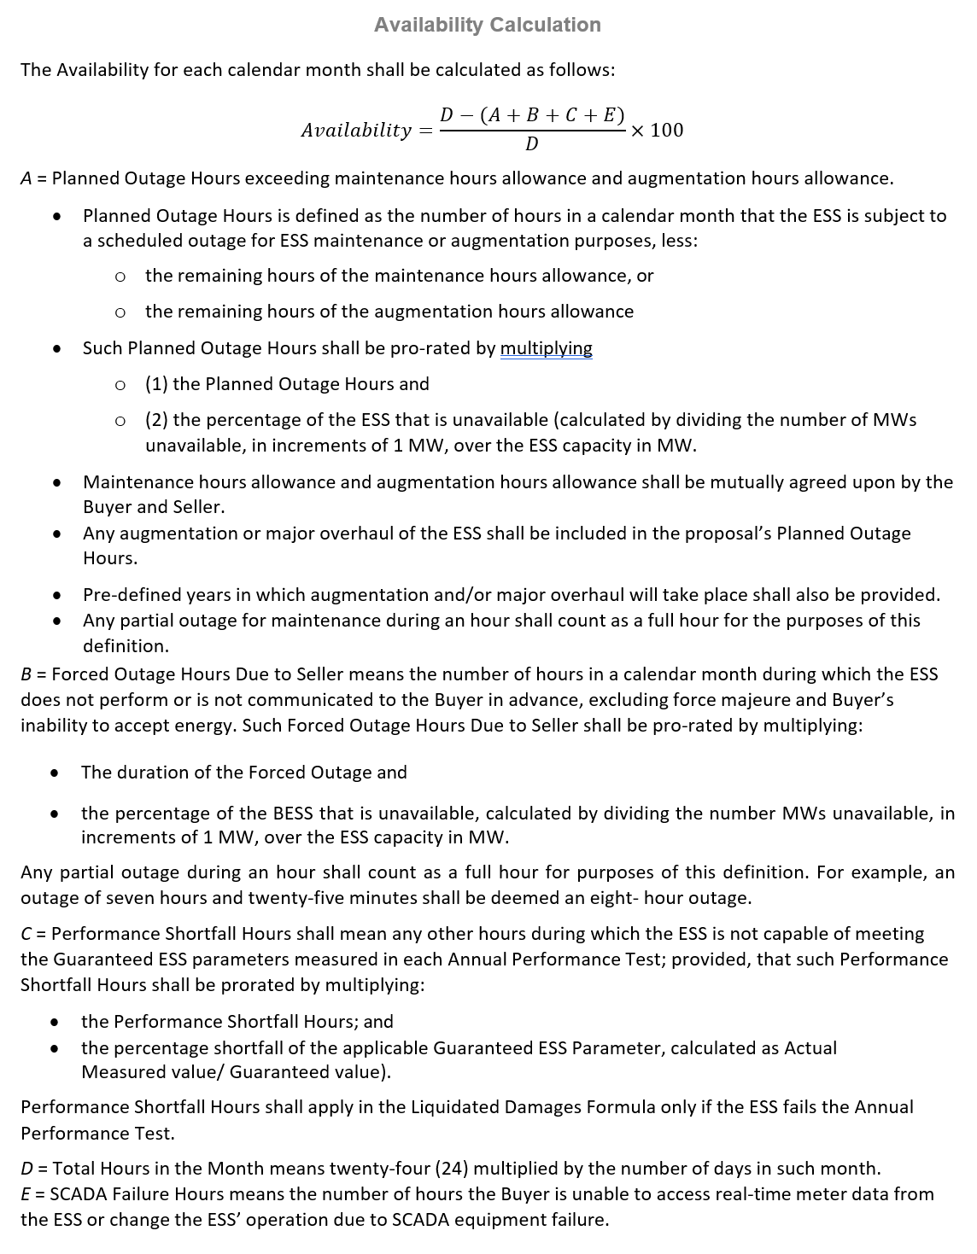
Availability Percentage
Figure 1: Availablity Calculation
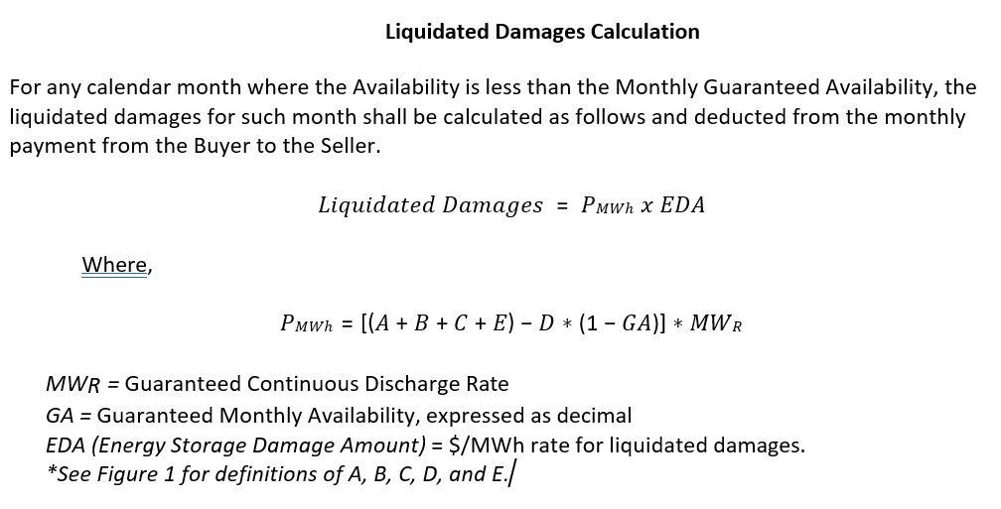
Figure 2: Liquidated Damages Calculation

Exhibit 1: ESS Specifications Datasheet

The Seller shall fill in the specified parameters in the attached ESS Specifications Datasheet as applicable. Please indicate N/A for non-applicable items.
Project Information | Response
Project Name
Project Description
Capacity (MW)
Duration (hours)
Energy Amount (MWh)
COD (20XX year)
Contract Length (year)
Specification/Parameter | Description | Unit | Value
Energy Storage Technology Type
RTE (%) |  | %
Availability Guarantee (%) |  | %
Minimum Generation Capacity |  | MW
Rated Continuous Discharge Real Power (MW) | The rate at which the ESS can continuously deliver energy for the energy storage component’s entire specified SOC range. | MW
Rated Continuous Charge Real Power (MW) | The rate at which the ESS can capture energy for the energy storage component’s entire* SOC range.  *The percent state of charge when the charge rate may be reduced near top of charge at end of life (EOL) | MW
Rated Storage Energy (MWh) |  | MWh
Energy Density (kWh/sq. ft.) |  | kWh/sq. ft.
Total Footprint (Acres) |  | Acres
Total Footprint (sq. ft.) |  | Sq. ft.
Response Time, Cold Start-up (seconds) |  | seconds
Response Time, Warm Start-up (seconds) |  | seconds
Useful Life (years) |  | years
Charge Ramp Rate (MW/min) |  | MW/min
Discharge Ramp Rate (MW/min) |  | MW/min

Specification/Parameter | Description | Unit | Value
Minimum Charge Time (hours) | The minimum amount of time required for the ESS to be charged from minimum SOC to its rated maximum SOC. | hours
Typical Charge Time (hours) | This should include any time for rest a period needed between a full or partial charge or discharge cycle. | hours
Degradation (%/year) |  | %/year
Cycles Limitation (cycles) |  | cycles
Rest Period between Cycles (hours) |  | hours
Warranty Term (years) |  | years
Expected Planned Down-Time for Maintenance (hr/yr) | Expected time required for regular maintenance and types of maintenance. | hr/yr
Expected Service Period between Regular Maintenance (days) | Specify | days
System Internal Minimum Temperature (°F) | System internal temperature if charging medium requires a certain temperature to work optimally (i.e. thermal storage) | °F
System Internal Maximum Temperature (°F) |  | °F
System Minimum Ambient Temperature (°F) | Minimum ambient temperature at which the system can operate at its rated capacity (also consider min/max temp limits when in standby or when idle). | °F
System Maximum Ambient Temperature (°F) | Maximum ambient temperature at which the system can operate at its rated capacity (also consider min/max temp limits when in standby or when idle). | °F
Range of Operational Humidity Range (%RH) | Range of humidity in which the ESS can operate according to its full specifications. | %RH
Sound Emissions – 6 ft High, 3 ft from Perimeter (dB) | Audible Noise dB at 3 ft distance (nearfield). | dB
Sound Emissions – 6 ft High, site boundary; approximately 40ft from ESS (dB) | Audible Noise dB at site boundary (approx. 40 ft). | dB
PM – Airborne Particulate Matter (lb/MWh) | Type, amount of emitted airborne particulates and under which conditions with respect to the energy through-put. | lb/MWh
Gas Emissions (lb/MWh) | Provide Type & amount of gas emitted, under which conditions with respect to the energy through-put. Examples include criteria pollutants (NOX, SOX), greenhouse gases (CO2, CH4, N2O, etc.) and fugitive emissions from cooling equipment and circuit breakers (refrigerants, SF6). | lb/MWh
System Operational Altitude Range | System Operational Altitude Range | ft.
Specification/Parameter | Description | Unit | Value
Fluids Containment Necessary (Moat, Tank, or Pond) | Type, amount, and under which conditions.
Output Voltage Range (p.u.) | The range of AC grid voltage under which the ESS will operate in accordance with the ESS specification. | p.u.
Self-Discharge Rate (%/hour) | when battery is shut down/in storage state | %/hour
Standby Loss Rate (%/hour) | when battery is on standby, ready to respond (not cold start) | %/hour
Rated Continuous Reactive Power (MVar) | The magnitude of continuous reactive power (Real Power = 0) and the duration that the ESS can provide this power without overheating. | MVar
Rated Continuous Apparent Power (MVA) | The real or reactive power (leading and lagging) that the ESS can provide into the AC grid continuously without exceeding the maximum operating temperature of the ESS. | MVA
Rated Continuous AC Current (A) | The AC current that the ESS can provide into the grid continuously and can be charged by the grid continuously without exceeding the maximum operating temperature of the ESS. | A
Max Real Power (WMax) | The maximum real power that the ESS can deliver to the grid, in Watts. May be the same as continuous discharge rate | MW
Max Apparent Power (VAMax) | The maximum apparent power for ESS, in Volt-Amperes. | MVA
Max Reactive Power (VARMax) | The maximum reactive power the ESS can produce or absorb, in VARs. | MVARs
Max Charging Real Power (WChaMax) | The maximum real power the ESS can absorb from the grid, in Watts (e.g. battery storage charging). Note that WChaMax may or may not differ from WMax. | MW
Max Charging Apparent Power (VAChaMax) | The maximum apparent power the ESS can absorb from the grid, in Volt-Amperes (e.g. battery storage charging). Note that VAChaMax may or may not differ from VAMax. | MVA
Overload Discharge Power (MW) | The magnitude of temporary real power (reactive power = 0) and the duration that the ESS can provide this power before overheating. | MW

Specification/Parameter | Description | Unit | Value
Overload Charge Power (MW) | The maximum grid overload capability of the ESS. | MW
Overload Reactive Disharge Power (MVar) | The magnitude of temporary reactive power (Real Power = 0) and the duration that the ESS can discharge before overheating. | MVar
Overload Reactive Charge Power (MVar) | The magnitude of temporary reactive power (Real Power = 0) and the duration that the ESS can charge before overheating. | MVar
Artg (RMS Amps) | A nameplate value, the maximum AC current level of the ESS, in RMS Amps. | RMS Amps
Auxiliary Power Components Required
Total Auxiliary Power Required |  | kW
Average Auxiliary Power Required - Continuous |  | kW
Total Auxiliary Power Required - Peak Power (Locked Rotor, etc.) | A nameplate value, the maximum AC current level of the ESS, in RMS Amps. | kW

Exhibit 2: Key Personnel Experience and Resumes
Exhibit 3: Project Information

Exhibit 4: Degradation Curve

